In the 18th and 19th centuries several people, not always well-educated, were recorded as being able to do remarkable calculations in their heads. Some were young children. Often they were unable to describe how they did their calculations. Jedediah Buxton, who lived in the 18th century, did incredible multiplications by doing additions of 60 and 15. Having little education, he didn’t know about billions or trillions and so had to invent his own number names: 1018 he called a tribe and 1036 he called a cramp.

Following are some of the questions posed to these human calculating wizards along with the times it took them to answer. *Using a calculator, can you beat their times?*

Jedediah Buxton (c. 1707-1772), a farm labourer from Derbyshire, could not write but the following are two of the many calculations he did in his head. *Can you beat him?*

How many cubic yards of earth would you need to remove to make a hole 426 feet long, 263 feet wide and 2.5 feet deep?

Jedediah answered correctly in 15 minutes.

If sound travels at 1142 feet in a second, how long will it take to travel 5 miles?

Jedediah answered correctly in 15 minutes.

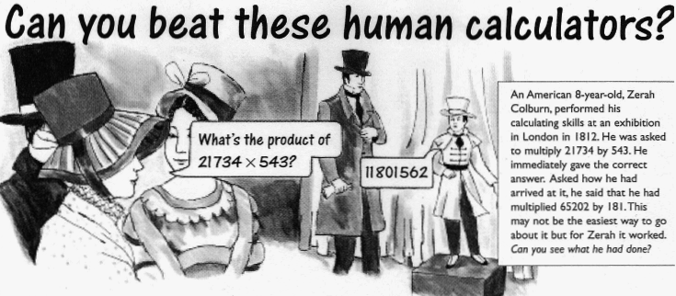George Bidder (1806-1878) was the son of a Devonshire stonemason. Below is a question put to him during the touring exhibitions he did when he was aged nine.

If the Moon is 123256 miles from the Earth, and sound travels at 4 miles a minute, how long would it take for cannon shot to be heard by an inhabitant of the Moon?

(The answer was given in days, hours and minutes.)

George answered correctly in 1 minute.

When George was fourteen he was given the following question:

If you live another 50 years and spend half-a-crown a day, how many farthings will you have spent in your life (In old money, half-a-crown was 30 pennies and each penny was worth 4 farthings.)

George answered correctly in 15 seconds.

Jacques Inaudi was born in 1867 in Italy. He spent his early years as a shepherd and spent many hours thinking about numbers. By the age of fifteen, unable to read or write, he was set this question at an exhibition in France:

How many seconds in 18 years, 7 months, 21 days and 3 hours?

Jacques answered correctly in 13 seconds.

Shakuntela Devi is a present-day human calculator from India. Her, recent book “Figuring: the joy of numbers” is now available in the UK describes some of the ways in which she has demonstrated making remarkable calculations in her head.